Abaher El Sakka, The Representations of Violence and Non-Violence in Palestinian Society

in Violence and Non-Violence across Time, History, Religion and Culture, Edited by Sudhir Chandra, Routledge. 2018.

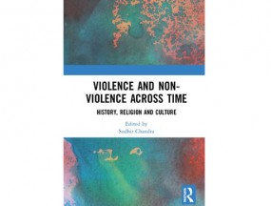Abstract

This paper aims at investigating the presence of the dichotomy of violence and non-violence in contemporary Palestinian political rhetoric and practice. To do so, I will explore the varied Palestinian discourses tracing from the contemporary back to the early twentieth century, where I will interrogate anti-colonials practice both in violent and non-violent modes. Throughout, I will map-out the different agencies and the fields of argumentation of each political entity, and its justifications as a group living under colonial conditions. This article consists of three parts: part I tackles the conceptual framework of the dichotomy of violence and non-violence; part II explores the historiography of the modes of violence and non-violence; and part III traces the controversy within Palestinian society over the topic at stake from the early 1900s until the present.

https://www.routledge.com/Violence-and-Non-Violence-across-Time-History-Religion-and-Culture/Chandra/p/book/9781138203297

