**Biomimetic catalytic activities of copper (II) ferrocenecarboxylate complexes with nitrogen based ligands as catechol oxidase and phenoxazinone synthase and for oxidative coupling of 2,6-dimethylphenol**

**A.Latif Abuhijleh**

***Chemistry Department, Birzeit University, P.O.Box14, West Bank, Palestine. E-Mail:*** [***latif@birzeit.edu***](mailto:latif@birzeit.edu)

Copper is one of the most important metals ,beside Fe and Zn, present in several metalloenzymes and is involved in a large number of biological functions including enzyme-catalyzed reactions [1]. Binary and ternary copper carboxylate complexes have been used as biomimetic of copper containing enzymes.

As part of our ongoing research on the study of biomimetic activities of copper (II) carboxylate complexes with biologically important nitrogen based ligands, we report here the results of our studies on the synthesis and oxidase catalytic activities of copper(II) complexes of ferrocenecarboxylate with nitrogen donor ligands pyrazole and 1,2-dimethylimidazole. The complexes, bis(ferrocenecarboxylato) tetrakis(pyrazole) copper(II) (1) and cis-bis (ferrocenecarboxylato) bis(1,2-dimethylimidazole) copper(II) (2) have been prepared from the reaction of tetrakis(ferrocenecarboxylato) bis(tetrahydrofuran) dicopper(II)and the appropriate base. Based on the spectral results for complex (1)**,** the Cu(II) ion is coordinated in the plan with four nitrogen atoms of pyrazoles and the axial sites are occupied by oxygen atoms from two ferrocenecarboxylato groups to yield Cu[N]sub4+ O[sub]2 chromophore. We had previously determined crystal structure of complex (2) by X-ray crystallography. In this complex the copper ion is in a cis- square-planar environment consisting of two imidazole nitrogen atoms and a carboxylate oxygen atom from each ferrocenecarboxylato ligand . The second oxygen atoms of the carboxylate functionalities are involved in weak interactions with the copper ion in the axial positions.

The biomimetic catalytic oxidase activities of complexes 1 and 2 toward the aerobic oxidations of 3,5-di-tert-butylcatechol (3,5-DTBC) to 3,5-di-tert-butyl-o-benzoquinone (3,5-DTBQ) (catecholase activity), and o-aminophenol (OAP) to o-amino-3H-phenoxazine-3-one (APX) (phenoxazinone synthase activity) have been studied and the results will be presented. In addition, the results of the catalytic activities of these complexes for C-O polymerization or C-C dimerization coupling of 2,6-dimethylphenol (DMP) will be presented

[1] S.E. Allen, R.R.Walvoord, R. Padilla-Salinas, and M.C.Kozlowski, Chem.Rev. 2013 ,113, 6214

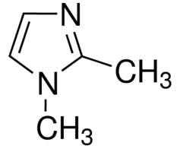 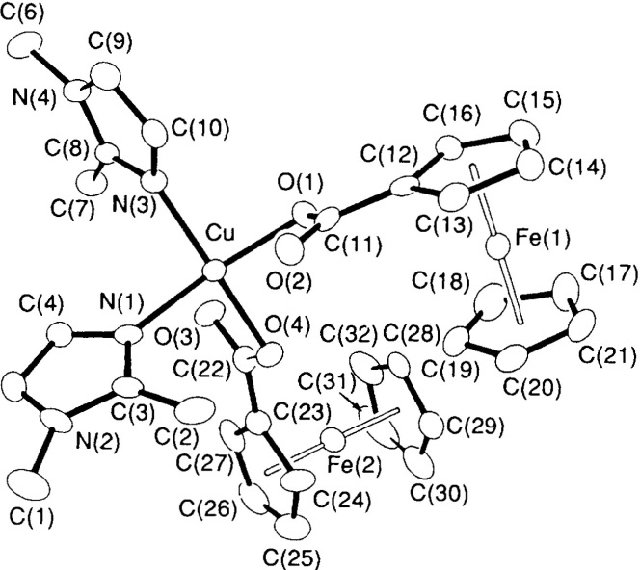

**1,2-dimethylimidazole**



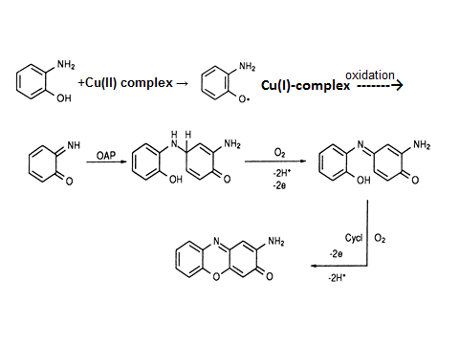

Catechol oxidase , phenoxazinone synthase and 2,6-dimethylphenol coupling oxidase biomimetic catalytic activities of copper (II) ferrocenecarboxylate complexes with nitrogen based ligands.

In addition, these complexes were found to be suitable catalysts for the oxidative polymerization of 2,6-dimethylphenol (DMP) to poly(1,4-phenylene ether) (PPE) in the presence of hydrogen peroxide as oxidant, and the results of their catalytic activities will be presented.

in water under mild conditions This final catalytic reaction mimic the final step in the biosynthesis of actinomycin D which is used clinically for the treatment of certain types of cancer. The formation of copper ion semiquinone species in the above oxidative reactions, which may be the catalytic intermediate that reacts with oxygen which leads to the formation of the respective product, will be discussed and is demonstrated spectrophotometrically.

These compounds were suitable as catalyst for the catalytic oxidation of 3,5-di-tert-butylcatechol (3,5-DTBCH(2)) to 3,5-di-tert-butyl-1, 2-benzoquinone (3,5-DTBQ) (catecholase activity), and o-aminophenol (OAPH) to 2-aminophenoxazine-3-one (APX) (phenoxazinone synthase activity) with dioxygen at ambient condition in good yields. Kinetic measurements revealed first-order dependence on the catalyst and dioxygen concentration and saturation type behavior with respect to the corresponding substrate. It was also found that the added triethylamine in both systems accelerates the reaction.

**Biomimetic catalytic activities of copper(II) ferrocenecarboxylate compl-exes with nitrogen based ligands as catechol oxidase and phenoxazinone synthase and for oxidative coupling of 2,6-dimethylphenol**

**A.Latif Abuhijleh**

**Chemistry Department, Birzeit Univer-sity, P.O.Box14, West Bank, Palestine. E-Mail: latif@birzeit.edu**

**We report here the results of our studies on the structure and oxidase catalytic activities of copper(II) comp-lexes of ferrocenecarboxylate with pyrazole and 1,2-dimethylimidazole. The complexes, bis(ferrocenecarbox-ylato) tetrakis(pyrazole) copper(II) (1) and cis-bis(ferrocenecarboxylato) bis-(1,2-dimethylimidazole) copper(II) (2) have been prepared from the reaction of tetrakis(ferrocenecarboxylato) bis(tetrahydrofuran) dicopper(II) and the appropriate base, stuctures are shown below**

 

**complex** **1 complex 2**

**The determined structure of complex 1 was based on the spectral results while the structure of complex 2 was determined by X-ray crystallography.**

***Biomimetic catalytic activities of the complexes***

**In this study, we present our results on the biomimetic catalytic activities of the two mono-nuclear complexes (1 and 2) as models for copper containing enzymes, which includes : (1)The oxidation of 3,5-di-tert-butyl-catechol as catecholase biomimetics. (2) the oxidation of o-aminophenol as phenoxazinone synthase oxidase mimetic activities. And (3) the catalytic activities of these complexes for C-O polymerization or C-C dimerization coupling of 2,6-dimethylphenol (DMP)**

***1. Catecholase Activity***

**Catechol oxidase is type 3 copper containing enzyme catalyzes exclu-sively the oxidation of catechols to the corresponding o-quinones**



**The catalytic activities of the complexes ,in methanol solutions, for the air oxidation of 3,5-di-tertbutyl-catechol (DTBCH2) to corresponding o-quinone (DTBQ) were followed spectrophotometrically by monitoring the absorbance increase of DTBQ formation at 400nm (ε=1800 M-1 cm-1 ) as a function of time (shown below)**

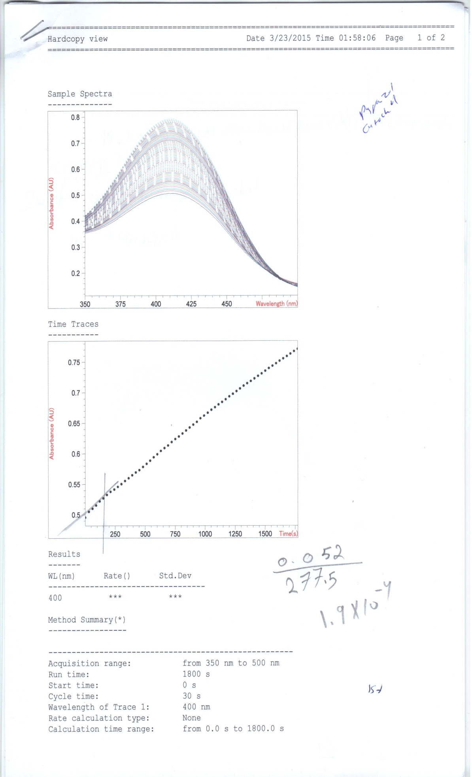

**The change in absorbance at 400 nm for the catalytic oxidation of** **DTBCH2 to DTBQ with complex (2)**

**It has been accepted now that the catecholase activity of mononuclear copper(II) complexes follows the mononuclear pathway as we and other researchers showed previously. In complexes understudies, DTBC binds to Cu(II) after its dehydrogenation (by ferrocenecarboxylate groups) to form Cu(II)–DTBC complex followed by an internal electron transfer to form Cu(I)–o–semiquinone intermediate species (I and II in the catalytic cycle –shown below)**

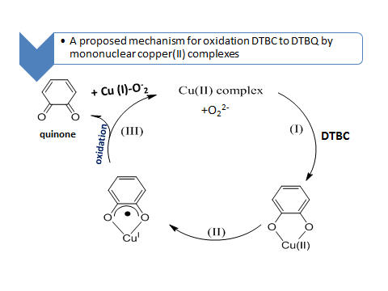

**Oxidation by aerobic oxygen occurs to produce o-benzoquinone (DTBQ) and Cu(II) complex as shown in (III) of the cycle. During the oxidation process , copper-superoxide adduct may form, Cu(I)-O-2 to give Cu(II) complex and peroxide O22-.**

**The formation of copper(I)- 3,5-di-t-butyl o–semiquinone intermediate during the oxidation process was demonstrated in this study by following the Uv-visible spectral changes of the catalytic reaction mixture. Copper(II) complex (2) (0.02 mmol) DTBC(0.44mmol) were mixed in 20mL degassed methanol under nitrogen and the Uv-visible spectrum of the intense green solution was recorded.**

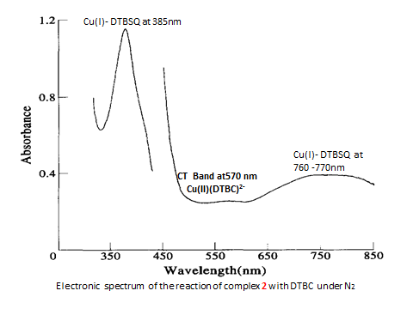

**The initial rate reaction shows a first-order dependence on the concentra-tion of complexes 1 and 2 and saturation kinetics with respect to 3,5-DTBC.**

***(2) Oxidation of o-aminophenol as phenoxazinone synthase oxidase mimetic activities***

**The enzyme phenoxazinone synthase,**

**a copper containing enzyme, catalyzes the oxidative coupling of two molecules of a substituted 2-amino-phenol to the phenoxazinone chro-mophore in the final step in the biosynthesis of naturally occuring antibiotic actinomycin D which is used clinically for the treatment of certain types of cancer.**

** ActinomycinD**

**The biomimetic catalytic oxidation of o-aminophenol (OAP) to 2-aminophe-noxazin-3-one(APX) by copper comp-lexes in methanol solutions were followed spectrophotometrically by monitoring the absorbance increase of APX formation at 433nm (ε= M-1 cm-1 ) as a function of time (shown below)**



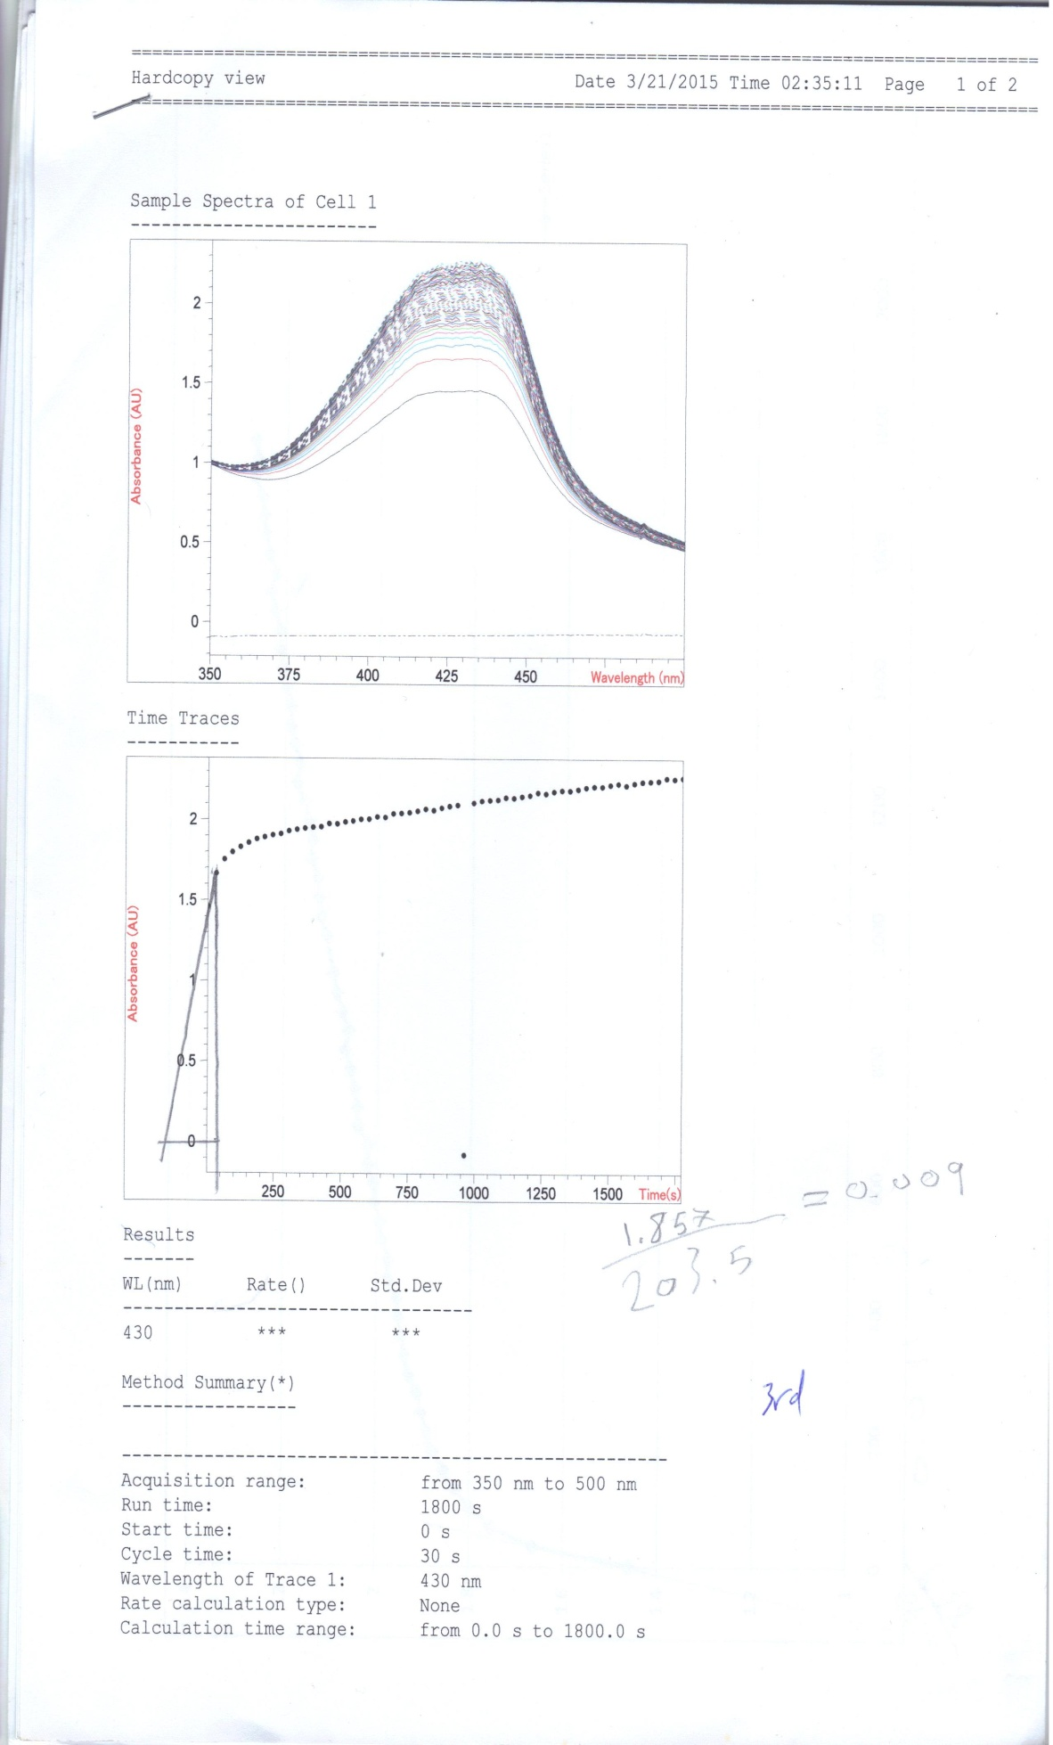

**The change in absorbance at 433 nm for the catalytic reaction of OAP to APX with complex (1) for the first 20 min of the reaction.**

**The proposed mechanism for this catalytic reaction is shown below:**

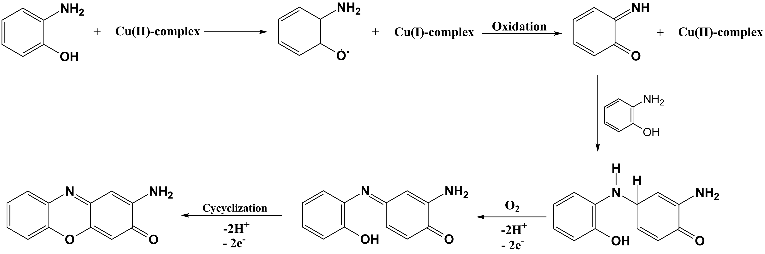

**(3)Catalytic oxidative** **coupling of 2,6-dimethylphenol (DMP)**

The general oxidative coupling reactions are shown below :

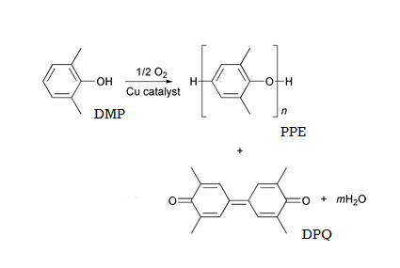

**Copper complexes catalyze oxidative polym-erization of 2,6-dimethylphenol (DMP) to produce poly(1,4-phenylene ether)(PPE) by C-O coupling and it is an important enginee-ring plastic with excellent mechanical prop-erties and chemical resistance. Another pro-duct is also produced as a result of C-C coupling which is diphenoquinone (DPQ)**

**and has a characteristic visible band at about 418 nm.**

